ASSIGNMENT - 8

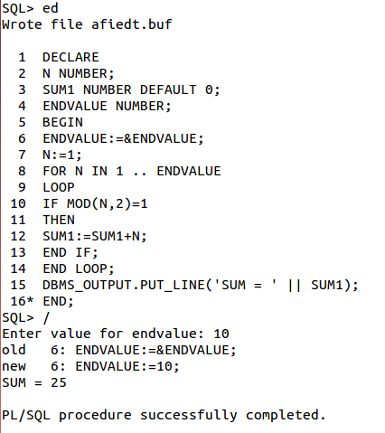

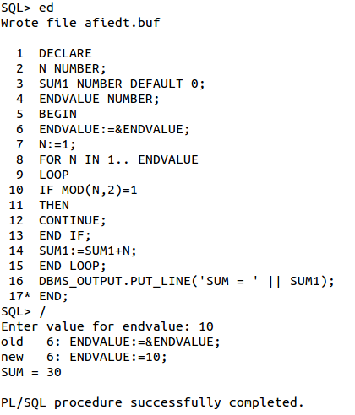

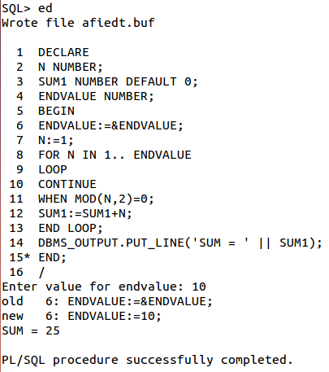

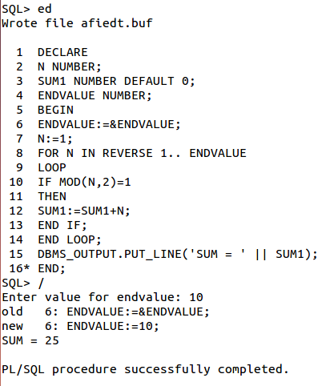

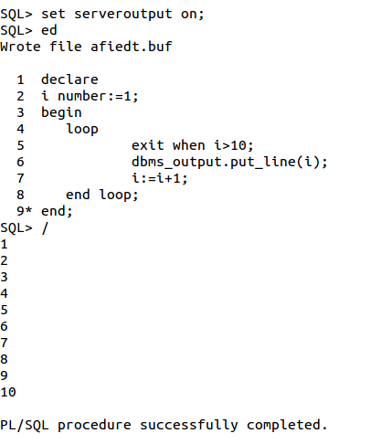

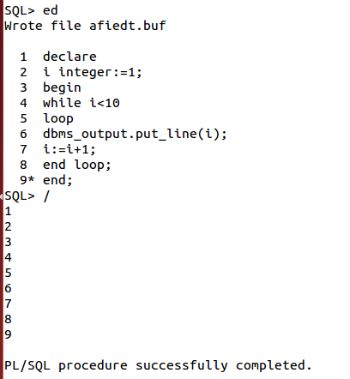

1. Implement a PL/SQL block that will accept student id number from the user, and check if the student attendance is less than 80% then display message that student cannot appear in exam. [Table: STUDENT (STUD_ID, primary key, STUD_NAME, STUD_ATT)].

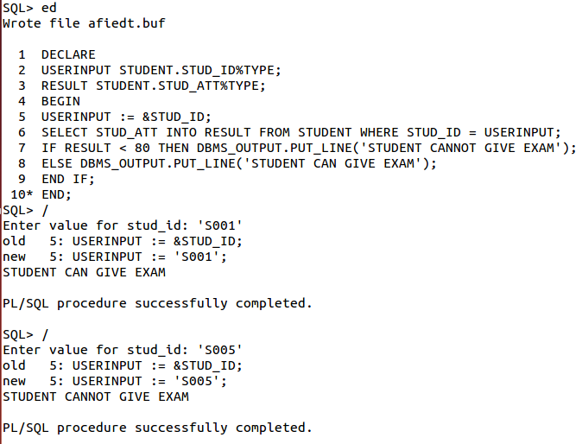

2. Implement a PL/SQL code block that will accept an account number from the user.
Check if the user’s balance is less than the minimum balance, only then deduct Rs.100 from the balance. The process is fired on the ACCT_MSTR table. [Table: ACCT_MSTR
(ACCT_NO, ACCT_HOLDR_NAME, CURBAL].

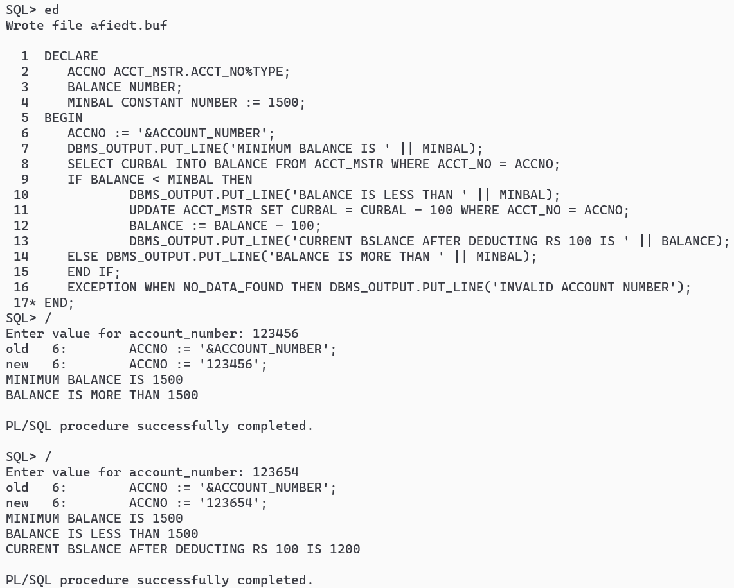

3. Implement a PL/SQL code block to calculate the area of a circle for a value of radius varying from 3 to 7. Store the radius and the corresponding values of calculated area in an empty table named AREAS, consisting of two columns Radius and Area. [Table:
AREAS (RADIUS, AREA)].

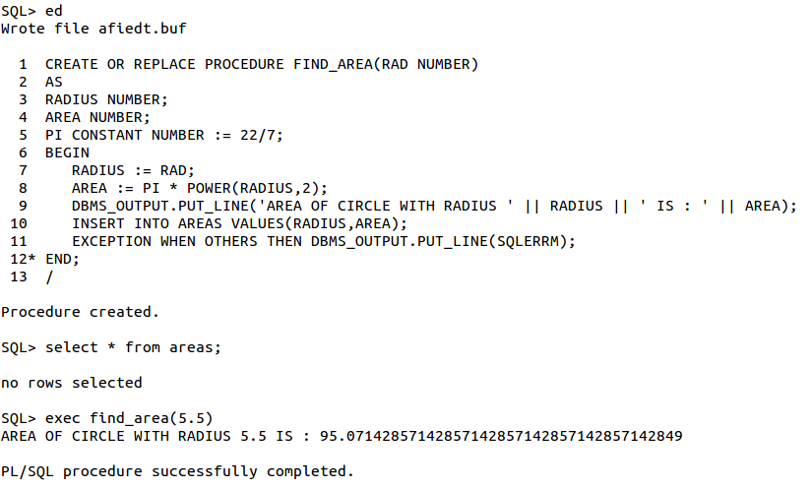
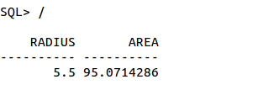

4. Implement a PL/SQL procedure that takes weight of an apple box as input from the user.
• If the
weight is >= 10 kg, rate =Rs. 5/kg.
• If weight is < 10 kg, rate = Rs. 7/kg.
Calculate the cost of the apple box. Display the output on the screen.

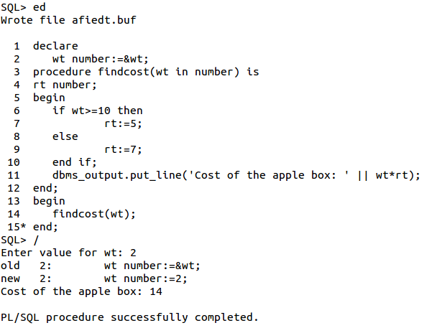

5. Implement a PL/SQL procedure to calculate the difference between highest salaried and
lowest salaried employee. Store the information in a table.

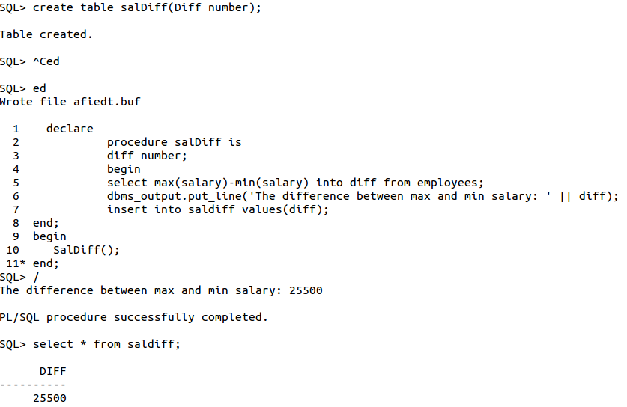

6. Implement a PL/SQL block using cursor that will display the name, department and the
salary of the first 3 employees getting lowest salary. [Table: Employee (ename, dept,
salary)]

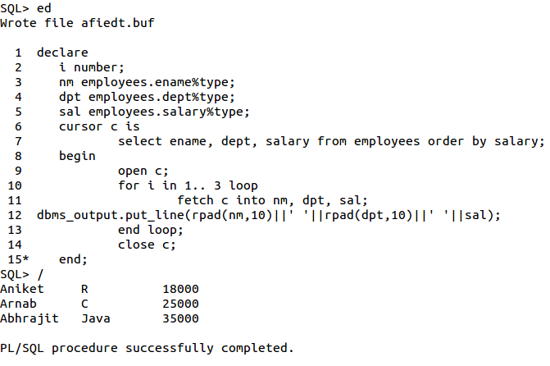

7. Implement a PL/SQL cursor that will update salary of all employees, such that, it allows
an increment of 20% if the salary is less than 2000 otherwise increment of Rs.1000. It
should print old and new salary for all employees. [Table: Employee (ename, dept,
salary)]

